Nmap Scanning Project Report
Subject: Network Scanning & Information Gathering
Tools: Nmap (Network Mapper)

1. Objective
To perform network scanning using Nmap to discover live hosts, open ports, running services, operating system details and to understand different types of port scanning techniques.

2. Tools Used
- Nmap (v7.94 or latest) - sudo apt install nmap on Linux
- Target: scanme.nmap.org (Official Nmap test server) OR 127.0.0.1 for localhost
- Terminal (Linux) / Command Prompt
- GitHub for report upload

3. What is Nmap?
Nmap (Network Mapper) is a free and open-source tool for network discovery and security auditing. It is used to find what hosts are available on the network, what services they are offering, what operating systems they are running and what type of packet filters/firewalls are in use.

4. Types of Nmap Scans
- Ping Scan (-sn): To find live hosts only, no port scan.
- TCP SYN Scan (-sS): Stealth scan, half-open scan, most popular.
- TCP Connect Scan (-sT): Full TCP connection scan.
- UDP Scan (-sU): To scan UDP ports.
- OS Detection (-O): To detect operating system.
- Version Detection (-sV): To detect service version running on ports.
- Aggressive Scan (-A): OS detection + version + script scanning + traceroute.
- Specific Port Scan (-p): Scan only specific ports like 80,443.

5. Practicals - Step by Step

Practical 1: Ping Scan - Find Live Hosts
Command:
nmap -sn 192.168.1.0/24
OR
nmap -sn scanme.nmap.org
What it does: It will show which IPs are online in your network without scanning ports.
Use for: First step to find targets.
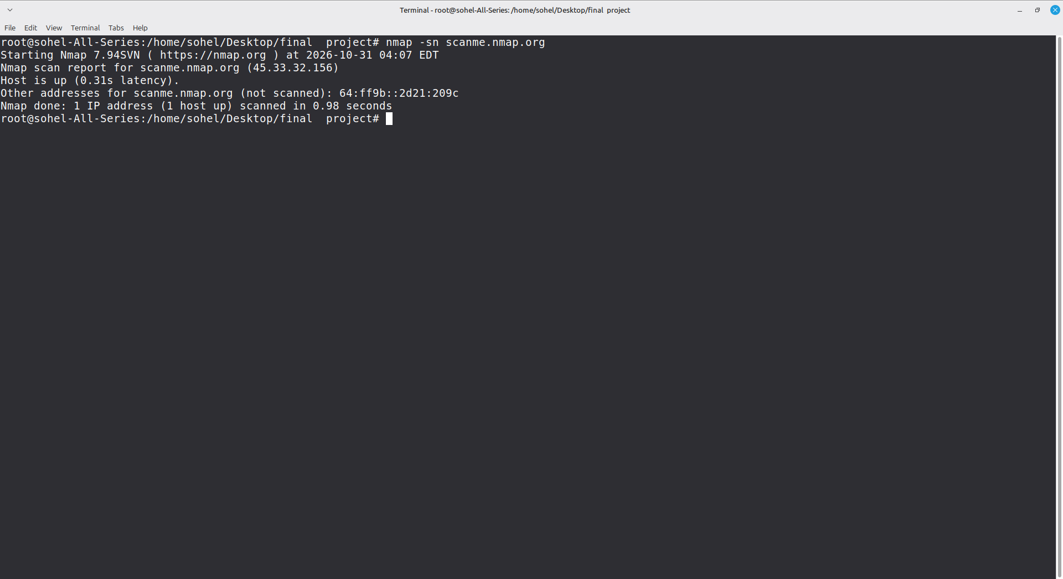

Practical 2: Basic TCP SYN Stealth Scan
Command:
sudo nmap -sS scanme.nmap.org
Output will show open ports like 22/tcp open ssh, 80/tcp open http
Note: Use sudo for SYN scan on Linux.
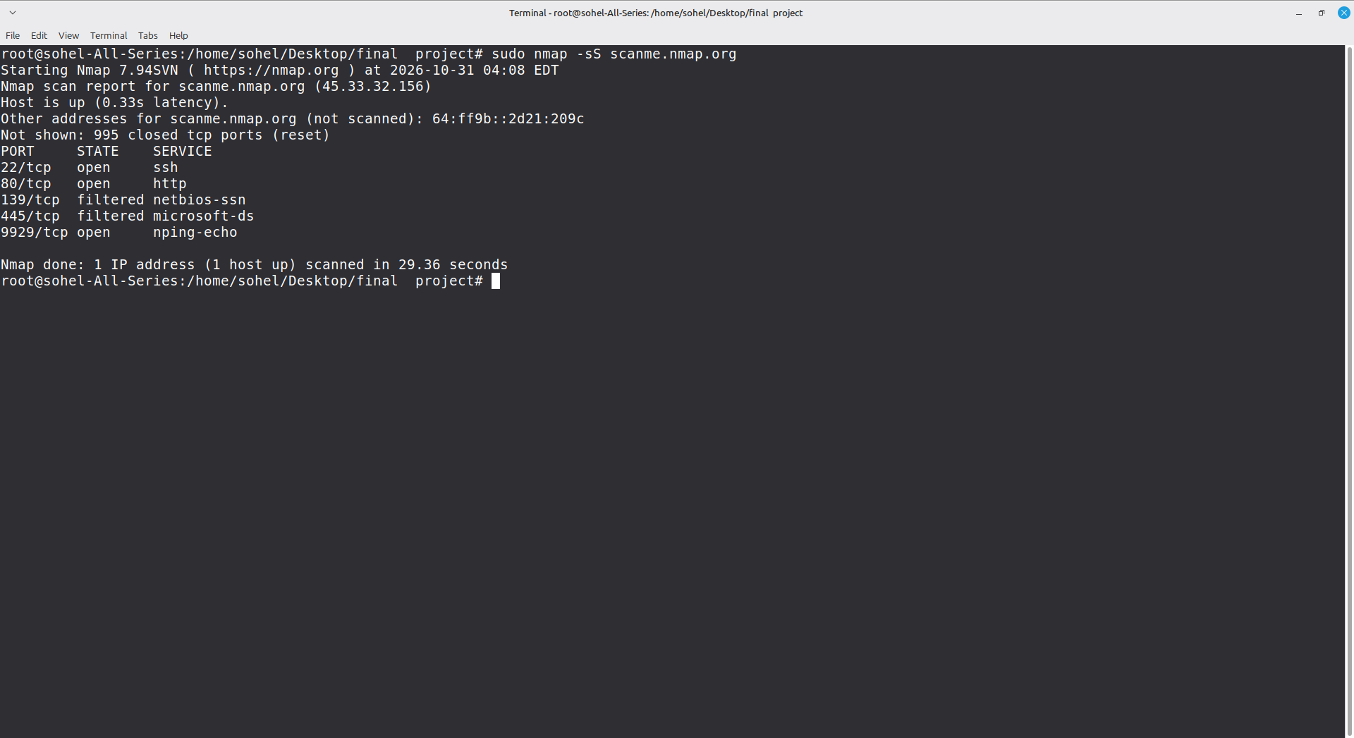

Practical 3: Scan Specific Ports
Command:
nmap -p 80,443,22 scanme.nmap.org
OR
nmap -p 1-1000 127.0.0.1
Useful when you want to check only web ports or specific services.
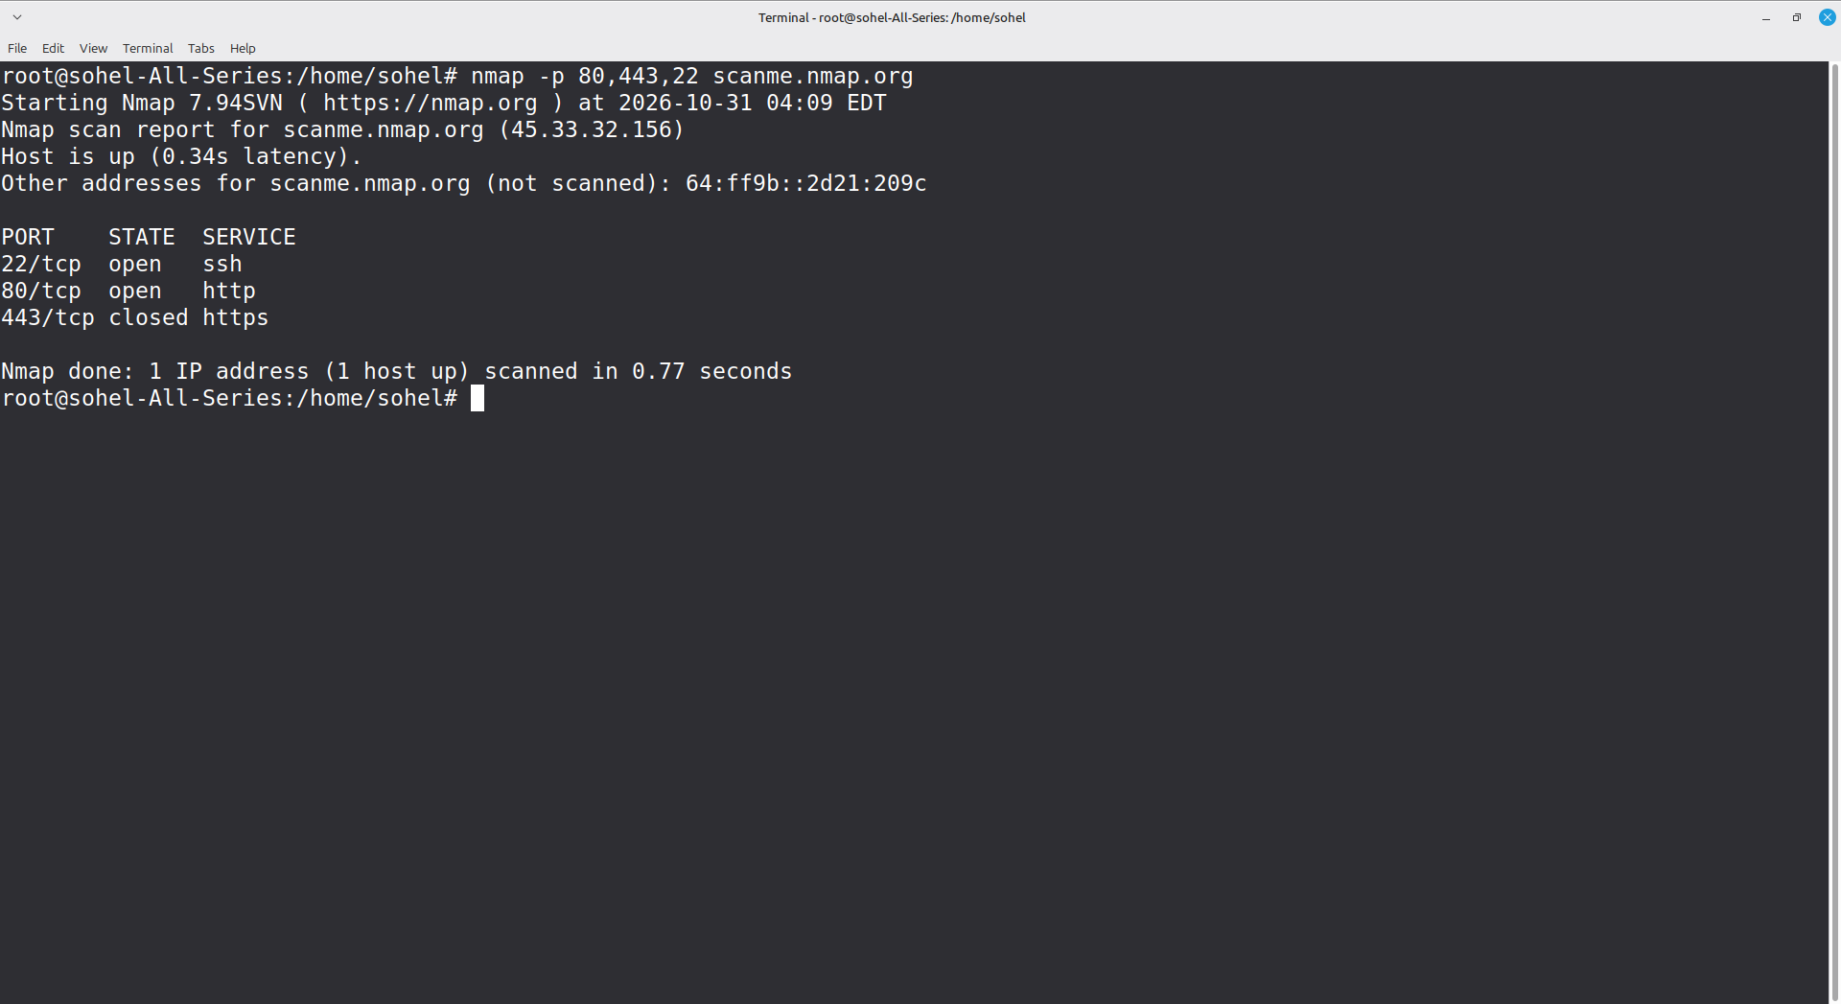

Practical 4: Service Version Detection
Command:
nmap -sV scanme.nmap.org
It will show service version like: 22/tcp open ssh OpenSSH 6.6.1p1, 80/tcp open http Apache httpd 2.4.7
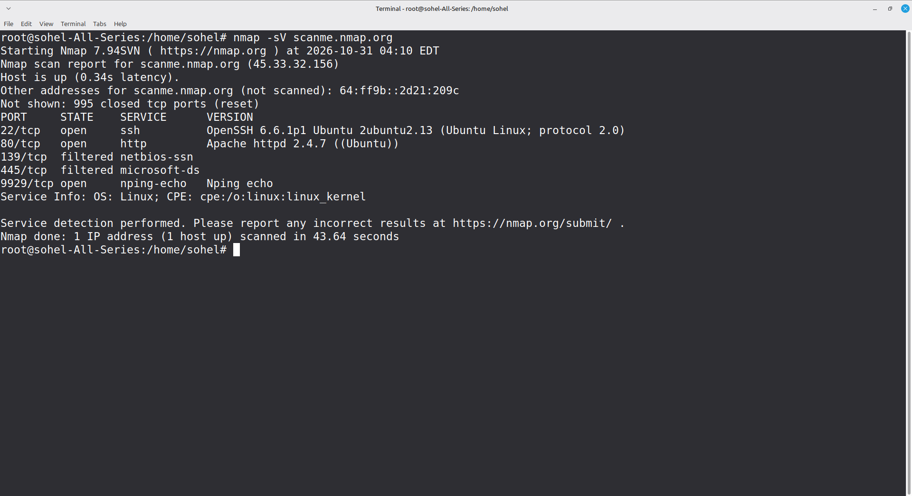

Practical 5: OS Detection
Command:
sudo nmap -O scanme.nmap.org
It tries to guess OS based on TCP/IP fingerprint. Example: Linux 3.2 - 4.9
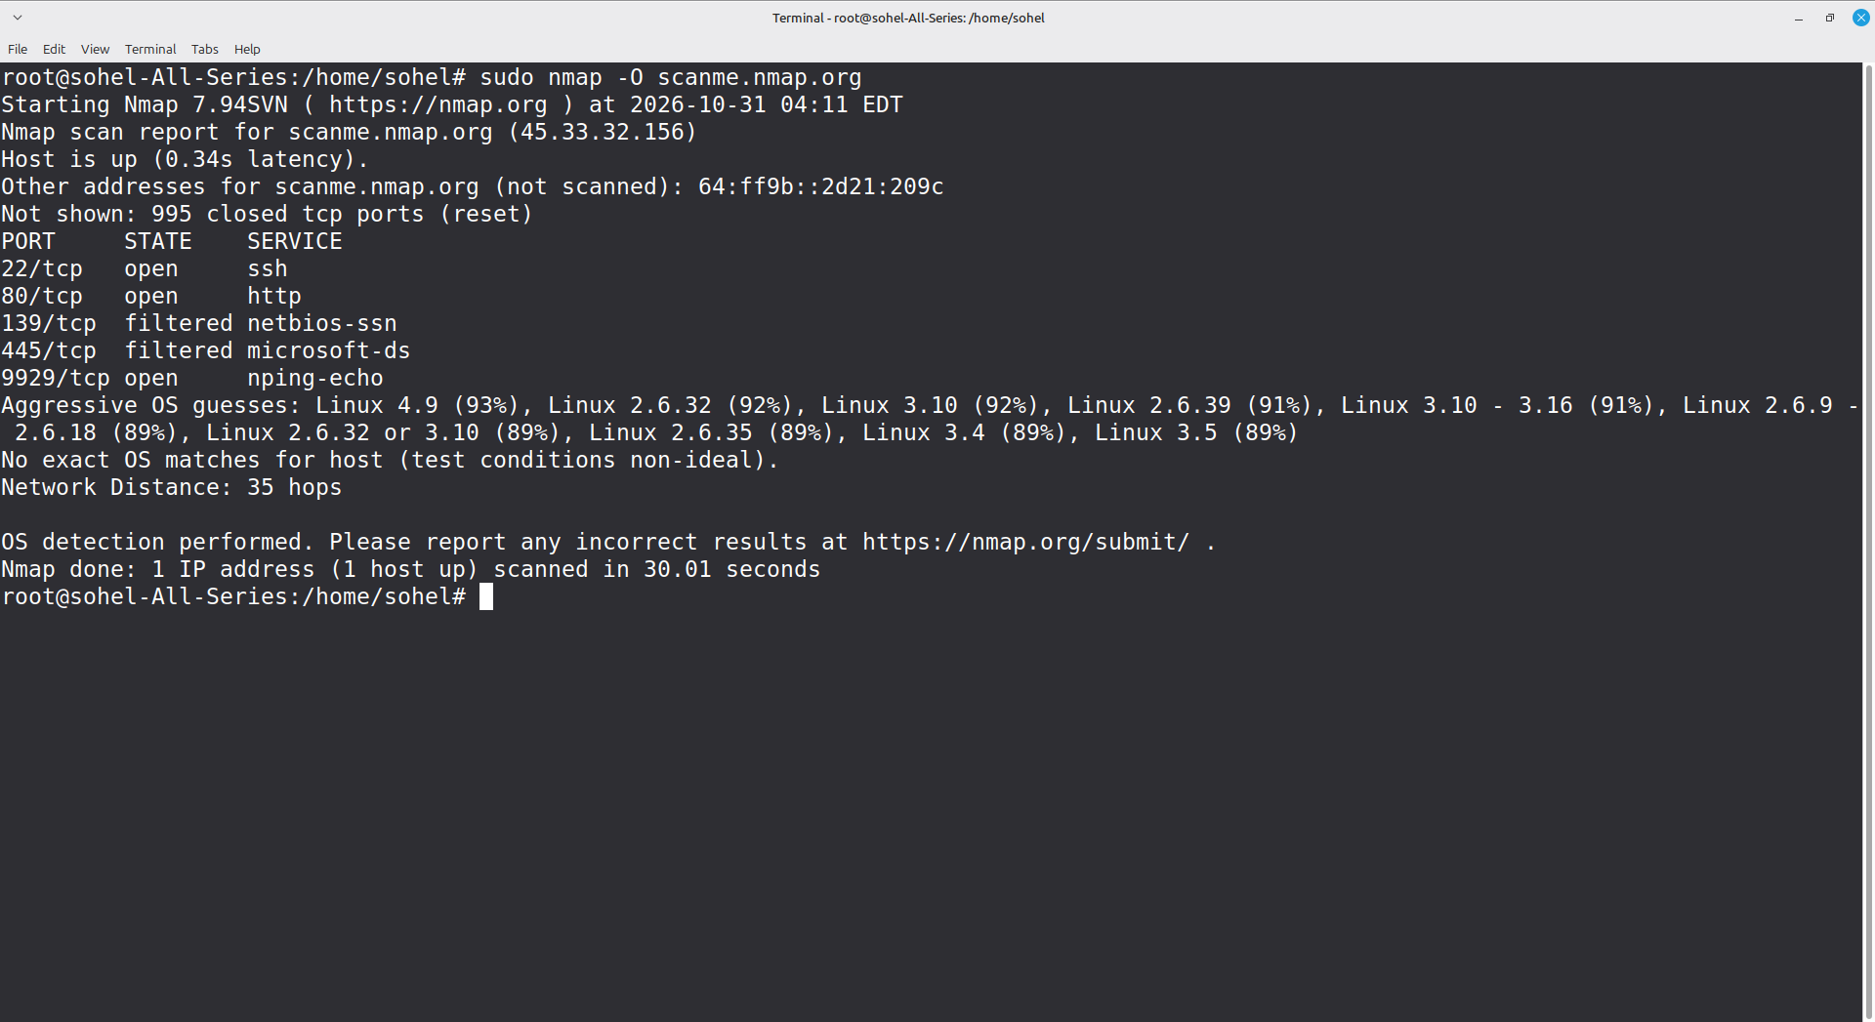

Practical 6: Aggressive Scan (All in One)
Command:
sudo nmap -A scanme.nmap.org
This does OS detection + version + traceroute + script scanning. Takes more time but gives full info.
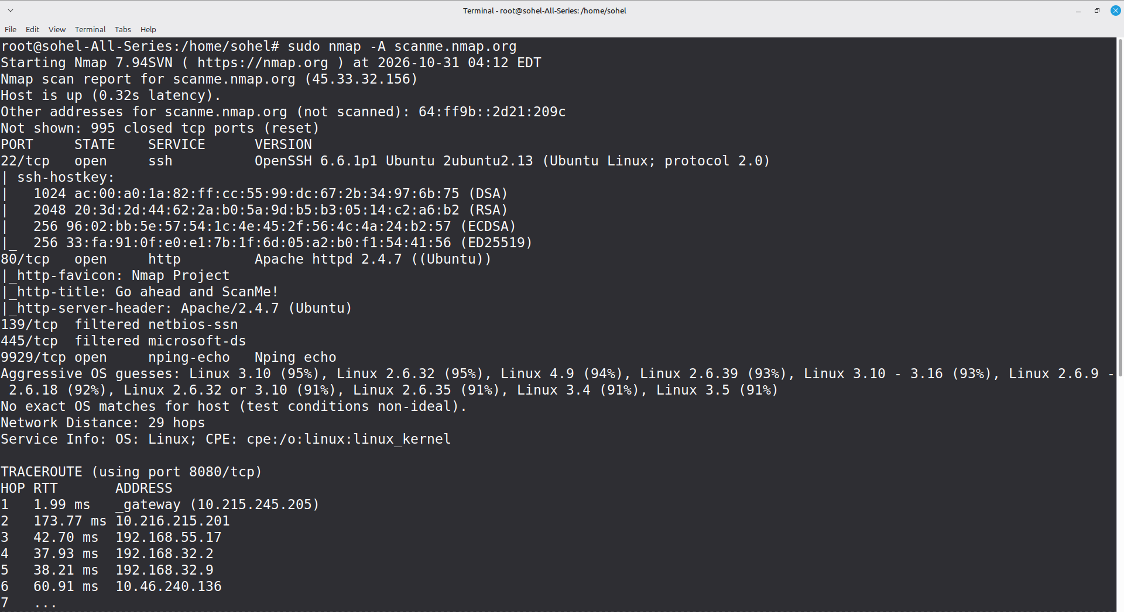
]

Practical 7: Save Output to File
Commands for saving:
nmap -oN scan-results.txt scanme.nmap.org (Normal text format)
nmap -oX scan-results.xml scanme.nmap.org (XML format)
nmap -oG scan-results.gnmap scanme.nmap.org (Grepable format)
This file will be uploaded to GitHub.
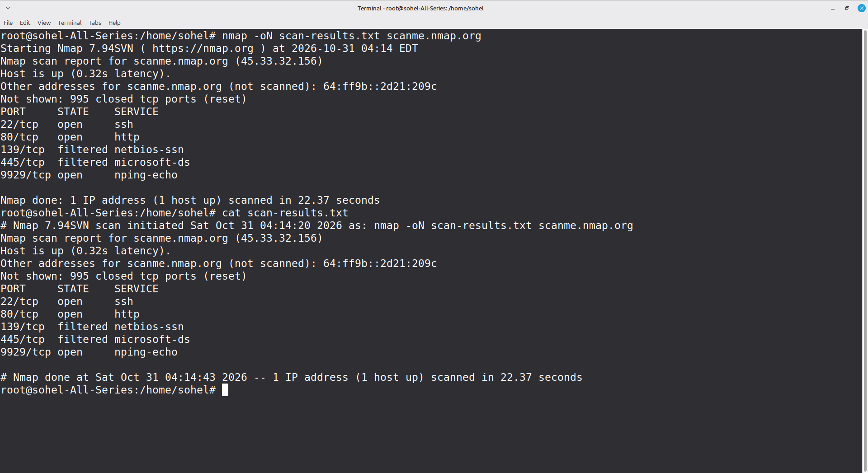

Nmap --script vuln
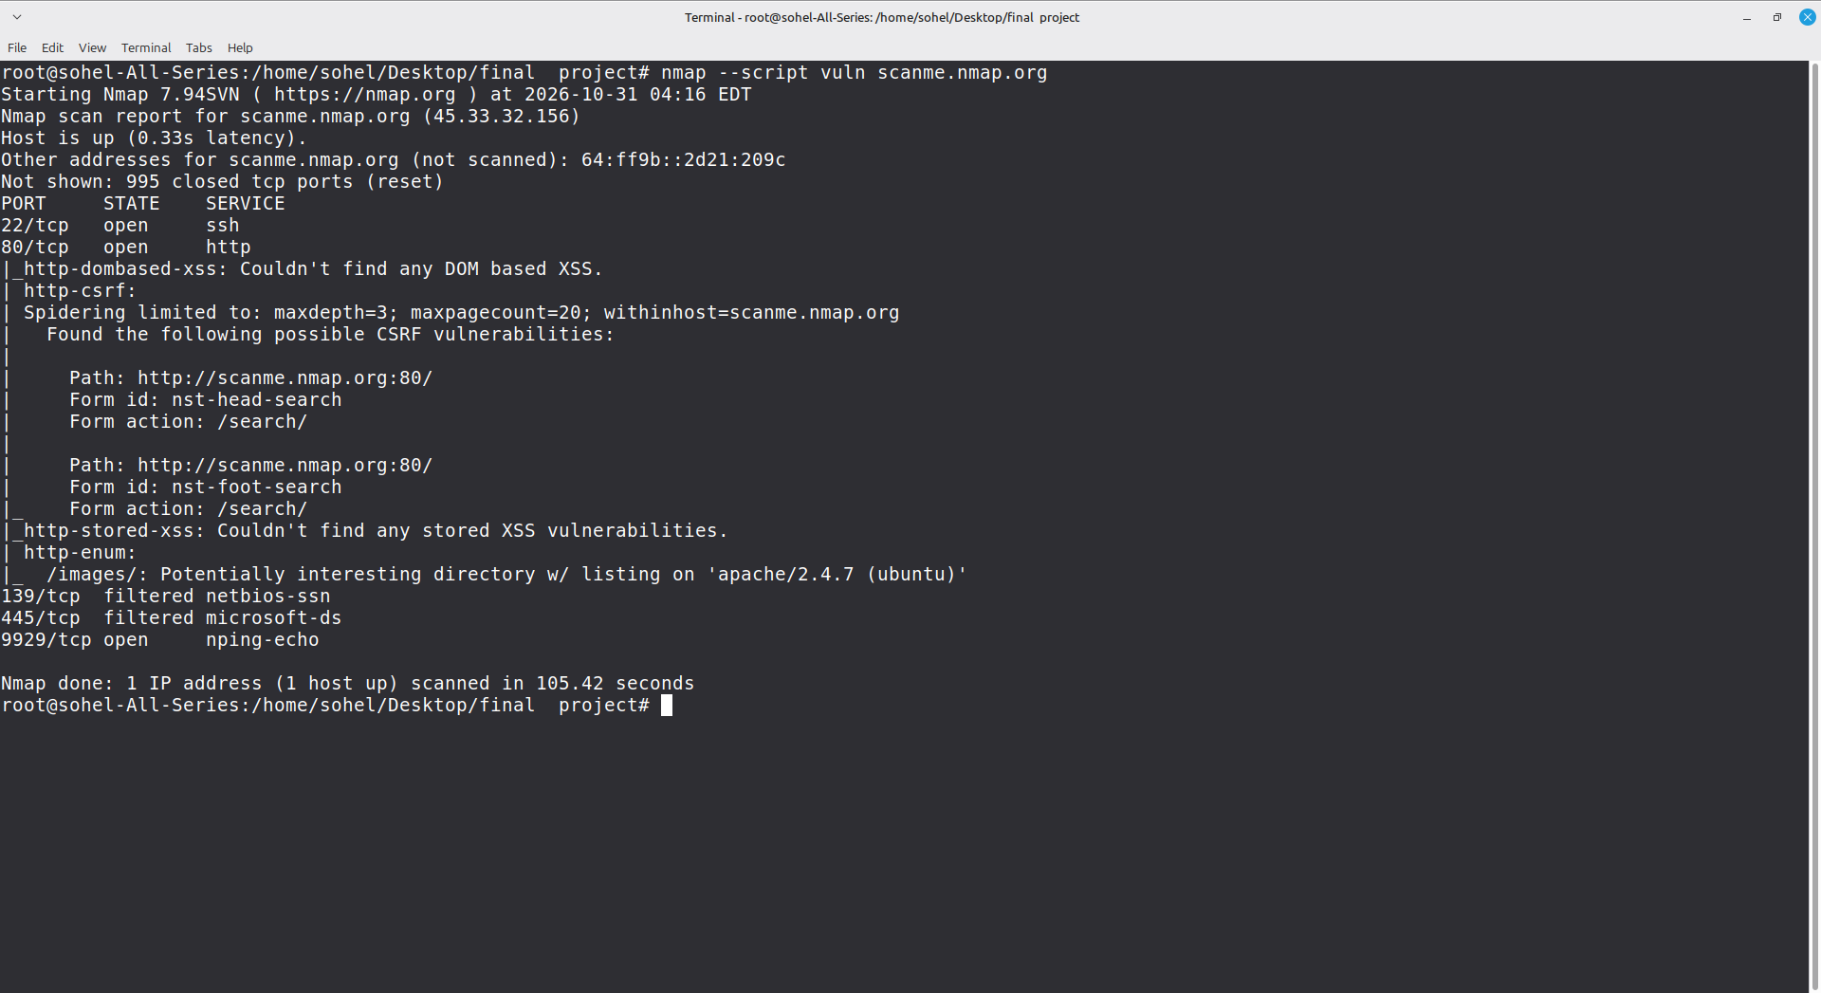
Nmap -sC


